Dorset Council UK Shared Prosperity Fund and Rural England Prosperity Fund
Round 1 Awards.

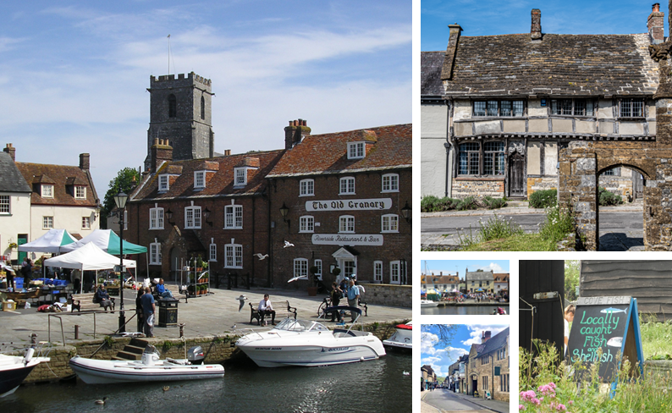

Round 1 Business Grants
12 December 2023 to 31 March 2024

Name of Enterprise | Grant Intervention | Project Summary | Capital / Revenue  Funding | Grant Awarded | Matched Funded
Sprint Signs Dorchester Ltd, Trading as Minuteman Press | E24 Business Growth Grant | Purchased of a HP Design Jet 64" printer and associated 64" cutter. | Capital | £4,000 | £4,000
Dmark Concepts | E18 Digital Technology and Automation Grant | Purchase a high-resolution 3D scanner and 3D printer | Capital | £20,000 | £32,594
Timber & Black Ltd | Rural England | Indespension Trailer, twin axle flatbed with extra mesh kit, ladder rack, spare wheel, and ramp. | Capital | £2,469 | £2,469
Weymouth 51 | Rural England | Labelling Machine | Capital | £10,352.50 | £10,352.50
Post Green Services Ltd | Rural England | Courtyard Centre Refurbishment | Capital | £20,000 | £80,000
Honeybuns | Rural England | Generator | Capital | £13,475 | £13.475
Farmer Palmers | E18 Digital Technology and Automation Grant | Website and new Booking System | Revenue | £8,287 | £8,287
Holland Street Design Ltd | E18 Digital Technology and Automation Grant | Computer design equipment | Capital | £983.99 | £983.99
Latent Drive Ltd | E20 Research and Development Grant | International Patent and Trademarks. | Revenue | £6,160 | £6,160
Basement Studio Ltd | E18 Digital Technology and Automation Grant | Computer Equipment | Capital | £3,200 | £3,298.33
Name of Enterprise | Grant Intervention | Project Summary | Capital / Revenue  Funding | Grant Awarded | Matched Funded
AG Tree Services Ltd | Rural England | Timber Trailer with Crane and ancillary items e.g. Flail Topper Mower, Tipping Grain Trailer. | Capital | £20,000 | £30,606
Lipco Engineering Ltd | E24 Business Growth Grant | Cyber Security Package, PC & Server | Capital | £19,507.50 | £19,507.50
Memo | E31 Feasibility Study | To complete due diligence work on the Eden Portland project and produce a feasibility study leading to a business plan. | Revenue | £22,500 | £67,500
Mauveworx | E18 Digital Technology and Automation Grant | Purchasing a new glue system and XY cutter to revolutionise the manufacturing process of premium coffins. | Capital | £16,233.03 | £16,233.03
Goldcrest Jewellers Ltd | E18 Digital Technology and Automation Grant | Website Design | Revenue | £3,311.40 | £3,311.40
Massif Ltd | Rural England | High Viscosity Filling Machine | Capital | £5,700 | £6,438
First Sanctuary Ltd | E18 Digital Technology and Automation Grants | Specialist Beauty Equipment | Revenue | £11,250 | £11,250
Collins Net | E18 Digital Technology and Automation Grants | Sage Software Systems and support costs | Capital | £9,856.90 | £9,857
Leisure Controls | R20 Research and Development Grants | Neat Compact Housing for Machines | Capital | £5,000 | £5,000
Curators of Taste Ltd (T/A Ogilvy & More) | Rural England | Shop Refurbishment | Capital | £20,000 | £32,000
Totals |  |  |  | £220,524.67 | £361,562.09

Community Awards Round 1
12 December 2023 to 31 March 2024
Name of Organisation | Funds Intervention | Project Summary | Capital / Revenue Funding | Grant Awarded | Match Funding
Royal Manor Theatre | E2 Community | Weatherproofing Building | Capital | £10,000 | £1,000
Weymouth Cougars | E2 Community | Storage Containers | Capital | £2,500 | £463
Beaminster Cricket Club | E2 Community | Training Facility Renewal | Capital | £5,000 | £13,962
The Burrough Harmony Centre, Bridport | E2 Community | Refit and Refurbishment | Capital | £6,000 | £11,600
Swanage Cricket Club | E2 Community | Extra Changing Room | Capital | £5,000 | £1,000
Marine Theatre | E2 Community | Programme for Cinema and Youth Academy | Capital | £15,000 | £33,124
Sixpenny Handley & Pentridge PC | E2 Community | Improving pedestrian accessibility to the Recreation Facilities | Capital | £15,000 | £10,000
Dorchester Arts | E2 Community | Modular Stage and LED Lighting | Capital | £4,800 | £3,000
Lytchett Matravers Parish Council | E2 Community | Energy improvements for Youth Hall | Capital | £9,500 | £1,252
Weymouth Museum | E2 Community | Moving Picture Project | Capital | £9,802 | £1,089
Totals |  |  |  | £82,602 | £76,490

Full details regarding the Dorset Council UK Shared Prosperity Scheme can be found at:
UK Shared Prosperity Fund - Dorset Council
All these project listed are part funded by the UK Government through the UK Shared Prosperity Fund.

