**Map Exercises 1**

Where did the evacuees come from?

Children were evacuated from all over England during World War II.

These are the **main** places children were evacuated from:

Liverpool

Manchester

Birmingham

The Black Country

London

Kent

Sussex

Essex

Southampton

Portsmouth

Channel Islands (evacuated to Dorset)

Nottingham

Using a map of Britain (*showing counties and cities)* and the blank map provided, find and place **Dorset**

* + Now find and plot the places children were evacuated from.
  + Which places are cities and which are counties?
  + Have you visited any of these places?
  + How long did it take to get there from your home in Dorset ?
  + Imagine doing this journey by yourself How do you think you might feel?
  + Are there some cities on the list that are not on the map? Can you find out where they are ? How will you do this?

MAP OF BRITAIN WITH COUNTIES AND MAIN CITIES

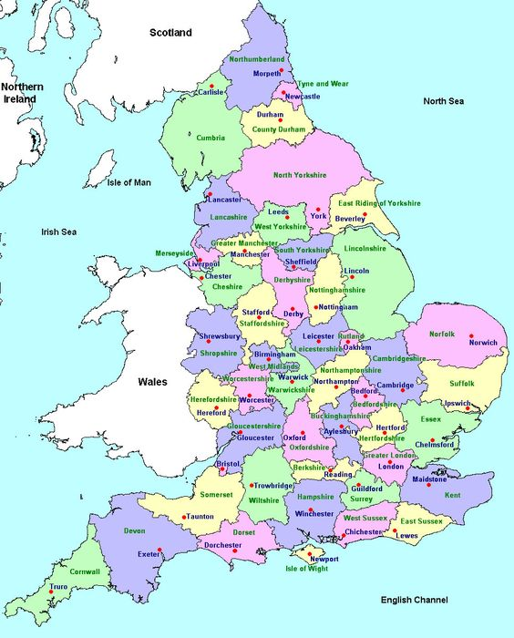

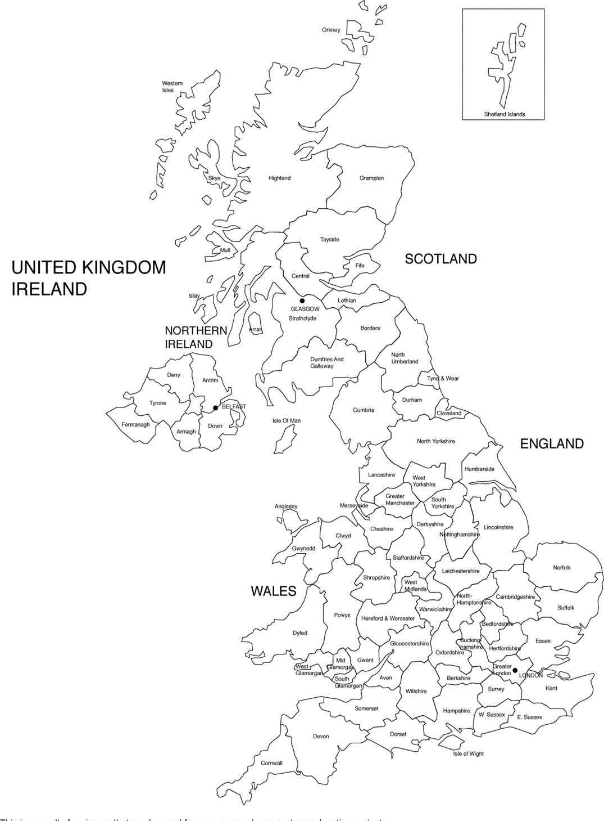

NAME:

Cities where WW2 evacuees travelled from.