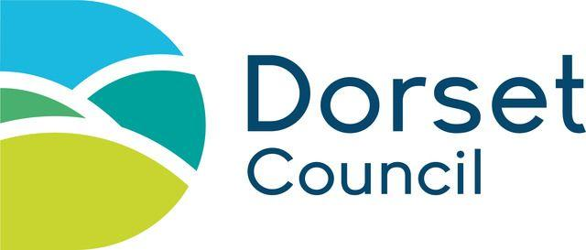
DofE Open Award Centre and Youth Project
Additional Information

1- 3 required for ALL ventures
4 required for wild country and overseas ventures only

Open Award Centre or Youth Project:……………………………………

Dates of Venture: ……………………………….

1. Supporting Staff (NOT including the Lead Supervisor OR Assessor)

Names of Additional Supporting Staff | Qualification held  ( eg C&C, BEL, SWM, ML etc) | 16 hr 1st aid  expiry date

2. Transport Details (personal insurance cover should include “business” if driving others)

Please provide details of all vehicles being used to support venture. Reg if possible | Against each vehicle list approved drivers | Against each vehicle please state whether insurance cover is;  Hire company, county, unit, private etc

3. Risk Assessment and Emergency Procedures
A full risk assessment plus emergency procedures details must be submitted with this form for all ventures

4. Green and Blue Forms are no longer required (as at March 2021)

However, wild country route overlays must be submitted with this form as you would have presented in the past. These can be in the form of gpx files.

