Pan Dorset Malnutrition Programme
Guidance notes for completing
‘MUST’ /Nutritional Screening electronic form
https://app.dorsetcouncil.gov.uk/MUST
Home and Community Care Pathway

Contents
General Information and Getting Started 2
To login for the first time: 2
To search for a client: 3
To view their existing records 3
To add a form 3
To add a client 4
Completing the form 4
CLIENT DOESN’T WISH TO BE WEIGHED OR CAN’T BE WEIGHED 5
Example of client NOT at risk of malnutrition: 5
Example of client AT risk of malnutrition: 6
CLIENT IS WILLING TO BE WEIGHED 6
Example of client NOT at risk of malnutrition: 6
Example of client AT risk of malnutrition: 7
ACTIONS TAKEN 8
NOT at risk of Malnutrition – Total Score 0 8
AT risk of Malnutrition – Total Score 1, 2, 3 or 4 9
Submitting the form 10
CEASING/SUSPENDING A ClIENT’S SCREENING 11

General Information and Getting Started

The Pan Dorset Malnutrition Programme Care Pathways should be followed to ensure the correct actions are taken.

Within the Electronic Form every option with a red Asterix* is mandatory and you cannot move to the next screen if you have not chosen an option or filled in information.

The majority of the fields will be automatically completed for you.

Where you see this drop down arrow select which option from the drop down menu that you want.

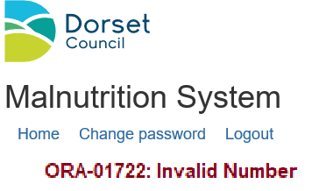
Error Code:
On rare occasions you may get an error message, this is because something has gone wrong in the system. If you were entering data, please re check the client you were working on and whether the information you have entered has been saved. If the data has not been saved please re-enter the data and try again. If this happens twice contact sue.hawkins6@nhs.net

To login for the first time:
Enter your user name. Click on ‘forgotten password’ and you will be sent an email with your password. Once you have logged in with the password you have been sent, you need to change it by going to ‘change password’
Use the same process if you forget your password.

To search for a client:

Input the client’s ‘NHS Number’ and choose ‘search’.
To view their existing records:
Click on the date field of the record you wish to view e.g. 05/03/2020 and the record will open.
(the button on the record will return you to the search screen)
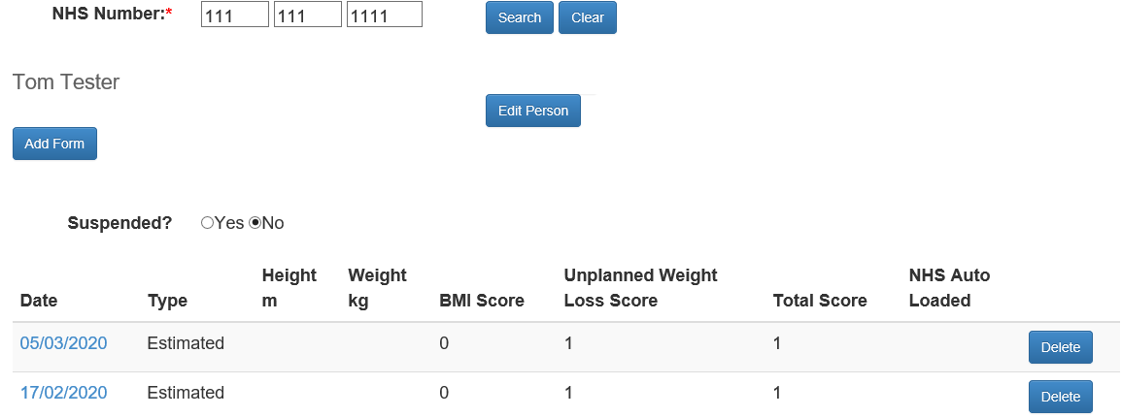
To add a form:

Choose the ‘Add a form’ button under the client’s name.

If your search does not find a record the screen will return ‘Person not found’

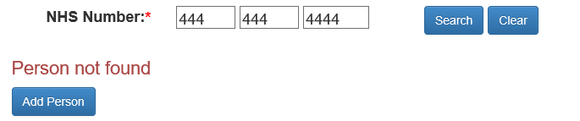

To add a client:
Click on the ‘Add Person’ button
The NHS number will be carried forward from your search. Input the ‘First Name’ and ‘Last Name’ of the client and choose the Locality of their GP practice from the drop down list.

There is currently only one form available, the ‘Home and Community Pathway’ form, so you do not need to choose the type of form required.

Click ‘Continue’

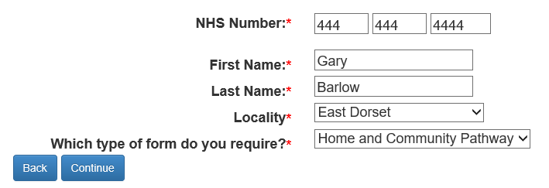

Completing the form

Choose the GP Practice of the client from the drop down menu
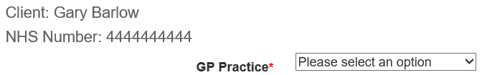
If the ‘GP Practice’ is not listed:
If the practice is not in Dorset, Poole or Bournemouth then they are not part of the programme. In which case, you need to contact the GP directly if the client has a medium or high risk of malnutrition.
If you believe the practice is within Dorset, Poole or Bournemouth then double check you are in the right GP locality. If the GP Practice is still not listed please contact sue.hawkins6@nhs.net

The content of the rest of the screen will depend on the information entered.

CLIENT DOESN’T WISH TO BE WEIGHED OR CAN’T BE WEIGHED

When a client doesn’t wish to or can’t be weighed e.g. it would distress them; they don’t have scales, the following questions appear:

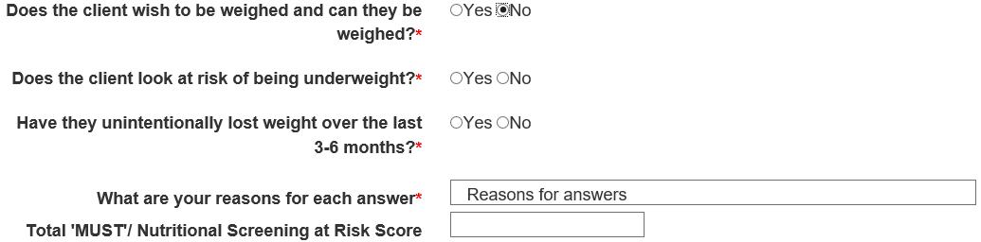
Complete accordingly as follows:

Does the client look at risk of being underweight i.e. Do you think they look very thin?

Have they unintentionally lost weight over the last 3 to 6 months? i.e. Check fit of clothes, jewellery, belts, what the client or their family tells you, refer to old photos.

It is essential to explain the reasons for you answers.

The Total ‘MUST’/Nutritional Screening at Risk Score is automatically calculated and will affect the actions to be taken that are then displayed (the Actions section is covered further down)

Example of client NOT at risk of malnutrition:
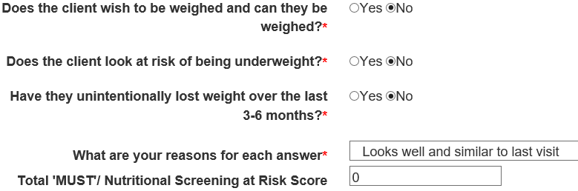

Example of client AT risk of malnutrition:

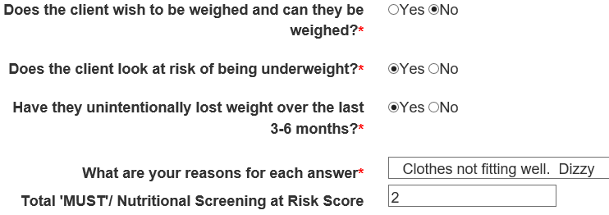

The Total ‘MUST’/Nutritional Screening at Risk Score is automatically calculated and will affect the actions to be taken that are then displayed (the Actions section is covered further down)

CLIENT IS WILLING TO BE WEIGHED
When the option of weighing is chosen, the following screen will appear:
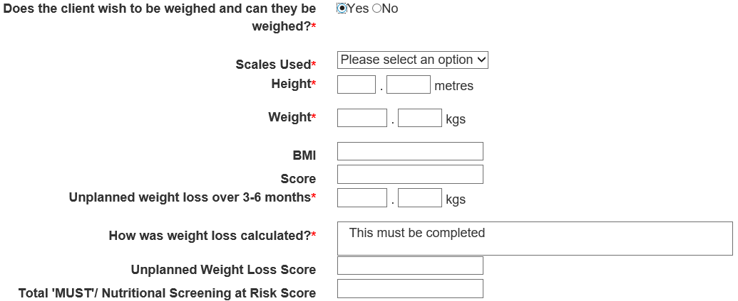

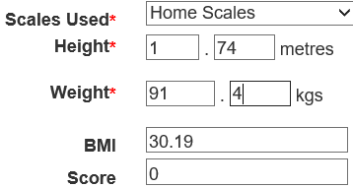
Example of client NOT at risk of malnutrition:

‘Scales Used’ will give the option of ‘Home Scales’ or ‘Staff Scales’. Please choose depending on which scales you have used.
Enter ‘height’ (m) and ‘weight’ (kg) The BMI and the equivalent ‘MUST’ BMI score will automatically be calculated
Next calculate or estimate their ‘Unplanned weight loss over the last 3 to 6 months’

Only record ‘Unplanned weight loss’. Planned weight loss should be recorded as ‘0’ and appropriate comments written e.g. ‘lost weight but on a planned diet’.
Their weight 3 to 6 months ago may be available from the system/notes/knowledge/observations. If there has been weight loss subtract today’s weight/current weight from their previous weight 3 to 6 months ago and enter into ‘Unplanned weight loss over 3-6 months’.
If previous weights are not available, you need to check fit of clothes, jewellery, belts, old photos, what the client or their family tells you. If weight loss is noticeable, assume 7kg (a stone) for an average sized person or 10kg (stone and a half) for a bigger person. If extremely noticeable increase the weights accordingly.
In this example the client has not lost weight or has put on weight in the last 3 to 6 months so ‘0’ is entered for the kilograms:
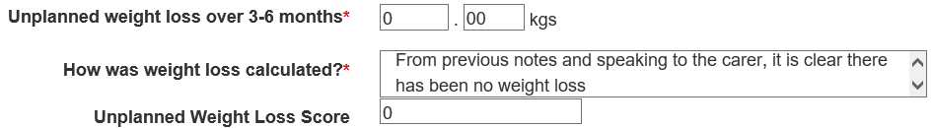
Then answer ‘How was weight loss calculated?’

Even if there is a ‘0’ as the unplanned weight loss score – as in this example - you still need to fill in ‘how this was calculated’ (e.g. ‘no weight loss observed’, ‘has been dieting’, ‘has put on weight’). It is essential to give a reason, be as precise as you can.

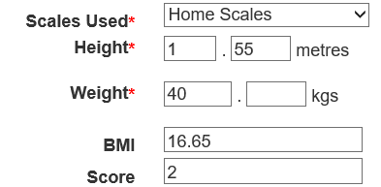
Example of client AT risk of malnutrition:
Choose ‘Scales Used’ from the option ‘Home Scales’ or ‘Staff Scales’

Enter ‘height’ (m) and ‘weight’ (kg)
The BMI and the equivalent ‘MUST’ BMI Score will automatically be calculated.

As you can see in this example the client has a “MUST” BMI Score of 2

Next calculate or estimate their ‘Unplanned weight loss over 3-6 months’

Only record ‘Unplanned weight loss’. Planned weight loss should be recorded as ‘0’ and appropriate comments written e.g. ‘lost weight but on a planned diet’.
Their weight 3 to 6 months ago may be available from the system/notes/knowledge or observations. If there has been weight loss subtract today’s weight/current weight from their previous weight 3 to 6 months ago and enter into ‘Unplanned weight loss over 3-6 months’.
If previous weights are not available, you need to check fit of clothes, jewellery, belts, old photos, what the client or their family tells you. .If weight loss is noticeable, assume 7kg (a stone) for an average sized person or 10kg (stone and a half) for a bigger person. If extremely noticeable increase the weights accordingly.

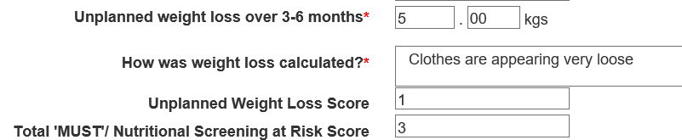

Then answer ‘How was weight loss calculated?’

Record your observations such as fit of clothes, jewellery, belts, old photos, what the client or their family tells you. It is essential to give a reason, be as precise as you can.

ACTIONS TAKEN

NOT at risk of Malnutrition – Total Score 0
When the client is NOT at risk of Malnutrition the ‘Provided Change for Life and Live Well Dorset Information’ will appear. Discuss if the client is looking overweight or obese and it is appropriate to do so.

Answer the question appropriately and add any notes or comments to support the decision.

Complete and submit the form (See Submitting the form further down)

AT risk of Malnutrition – Total Score 1, 2, 3 or 4

A larger list of questions will appear if the client is AT risk of Malnutrition

For the following questions choose ‘Yes’ or ’No’ and add appropriate notes and/or comments:

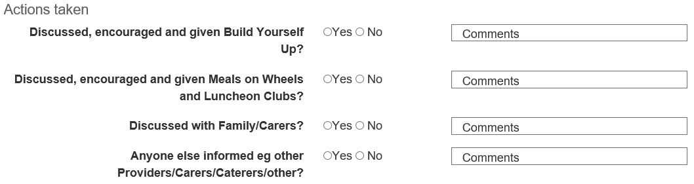
‘Are you planning to revisit to repeat screening’ – ‘YES’
If you ‘are planning to revisit’, click ‘yes’ and enter the ‘approximate date for next ‘MUST’ planned revisit.

(If using Internet Explorer 11 you will need to type in the date in the format dd/mm/yyyy, in any other browser a calendar date picker should appear when you enter the field)

‘Action required from Health & Social Care Co-ordinator’
You require action from the Health and Social Care Co-ordinator if one of the following statements is correct.
- You do not plan to revisit and the client has a total “MUST score of 1,2,3 or4
OR
- The client has had a total ‘MUST’ score of 2, 3 or 4 for two consecutive months with no improvement.
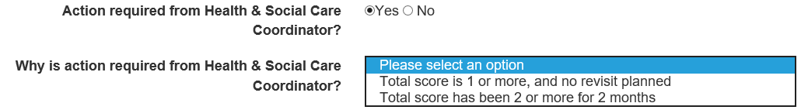

If you ARE revisiting AND action is required from the Health and Social Care Co-ordinator.
Click ‘Action required from Health and Social Care Co-ordinator’, and select from ‘Why is action required from the Health and Social Care Co-ordinator’ the option ‘Total score has been 2 or more for 2 months’ (if this isn’t the case i.e. the score is a 1 or has only been a 2 for only one month amend the answer to ‘Action required from Health and Social Care Co-ordinator’ to ‘NO’)

When the ‘Action Required from the Health and Social Care Co-ordinator’ is ‘Yes’ an email is automatically generated to the locality H&SCC’s requesting them to ensure appropriate actions have been taken.

‘Other Actions’ – please complete with any actions that you have or are planning to take e.g. raising at MDT/ Virtual Ward, informed GP, District Nurse etc.

Complete and submit the form (See Submitting the form further down)

‘Are you planning to revisit to repeat screening?’ - ‘No’
If you ARE NOT revisiting and the client is at risk of malnutrition (‘MUST’ score of 1 or more) then ‘action’ is required.

Choose ‘Action required from Health and Social Care Co-ordinator’ (as above)

Then from the ‘Why is action required from the Health and Social Care Co-ordinator?’ Choose option ‘Total score is 1 or more, and no revisit planned’

When the ‘Action Required from the Health and Social Care Co-ordinator’ is ‘Yes’ an e mail is automatically generated to the locality H&SCC’s requesting them to ensure appropriate actions have been taken.

‘Other Actions’ – please complete with any actions that you have or are planning to take e.g. raising at MDT/ Virtual Ward, informed GP , District Nurse etc.

Complete and submit the form (See Submitting the form further down)

For information: If a client has a total ‘MUST’ score of 4 the H&SCC will be automatically emailed for them to ensure appropriate actions are taken.

Submitting the form
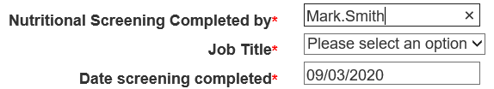
Fill in ‘Nutritional Screening Completed by’ - This is the name and person who completed the nutritional screening, not necessarily the person who completed the electronic form. It will automatically fill with the person entering the detail, but this can be amended.

‘Job title’: choose from the drop down menu
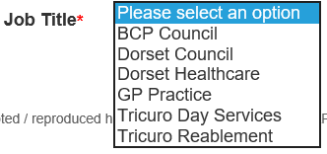
‘Date screening completed’: This should be the date that the screening was completed not when entered into the system. It will automatically fill with the current date, but can be amended. (If using Internet Explorer 11 you will need to type in the date in the format dd/mm/yyyy, in any other browser a calendar date picker should appear when you enter the field)
Press the button to save the form

You will then see a box like this, on which you should click ‘OK’:-

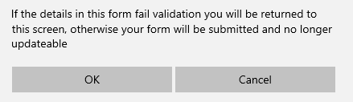
If you have completed all the information correctly you will return to the client’s front screen and the screening will have been added to the client’s list of screenings.

If you have not completed all of the mandatory fields you will be automatically returned to your form and the boxes requiring completion will have red text below them saying what additional information is required.

If for some reason you want to leave the input screen without saving any of your input, use the ‘Cancel’ button.

CEASING/SUSPENDING A ClIENT’S SCREENING

This can be used if a client is no longer part of the Malnutrition Programme. Set ‘Suspended?’ to ‘Yes’ and choose the reason from the drop down box. 