Flood Investigation Report

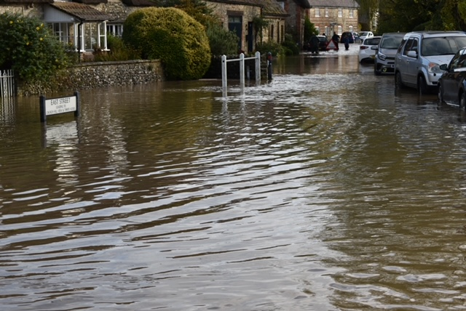

# Sydling St. Nicholas

# 31st October 2021 Flood Event

Table of Contents

_Toc103775172

1. Introduction 3

2. Risk Management Authority Responsibilities 4

3. Study Area Description 5

3.1 Geology and Hydrogeology 6

3.2 Hydrology 8

4. Incident Summary 9

4.1 Rainfall data 11

4.2 Locations Affected 20

4.2.1 East Street 20

4.2.2 High Street 21

5. Quick Wins 22

6. Recommended Actions 23

7. Next Steps 26

Appendix 1 – Catchment of the Study Area 27

## Introduction

The Flood Risk Regulations 2009 and the Flood and Water Management Act 2010 (the Act) have established unitary and upper tier local authorities as the Lead Local Flood Authority (LLFA) for their area. This has placed a number of responsibilities on the LLFA in relation to flood risk management and in particular Section 19 of the Act which states:

**Flood and Water Management Act 2010: Section 19 – Local Authorities: investigations**   
1) On becoming aware of a flood in its area, a lead local flood authority must, to the extent that it considers it necessary or appropriate, investigate -   
a) Which risk management authorities have relevant flood risk management functions, and   
b) Whether each of those risk management authorities has exercised, or is proposing to exercise, those functions in response to the flood.   
2) Where an authority carries out an investigation under subsection (1) it must -   
a) Publish the results of its investigation, and   
b) Notify any relevant risk management authorities.

When considering if it is necessary or appropriate to investigate a flood event Dorset Council will review the severity of the incident, the number of properties affected and the frequency of such an occurrence. Dorset’s Local Flood Risk Management Strategy clearly sets out the criteria to be used when considering a Flood Investigation Report.

This report has been produced to comply with legislation and to determine the main causes of the flooding. Each affected area will have a number of recommended actions to be taken forward by the relevant Risk Management Authorities (RMA’s) or in some cases, by the landowner or local community action group.

## Risk Management Authority Responsibilities

The general RMA responsibilities in relation to flood risk and surface water management are outlined below:

* **The Environment Agency (EA)** is responsible for managing the risk from the sea, main rivers and reservoirs and has a strategic overview role for all flood risk management, making it a key local partner for DC, especially when managing the risk from combined sources and in the event of a large flood incident. The EA also provides a flood warning service throughout England and Wales in areas at risk of flooding from rivers or the sea.
* **Dorset Council as the Lead Local Flood Authority (DC LLFA)** is responsible for the management of the flood risk from ordinary watercourses, groundwater and surface water runoff. It is also responsible for consenting to works on and enforcing the removal of any unlawful structure or obstruction within ordinary watercourses. DC must also prepare a Local Flood Risk Management Strategy, maintain a record of flood risk assets and undertake flooding investigations. It is also a statutory planning consultee for the management of surface water drainage to major developments (ten or more houses and commercial development of floor space greater than 1000m2 or sites larger than 1Ha)
* **Dorset Council as the Highway Authority** maintains the highway drainage system to reduce the amount of standing water on the highway. This is achieved by limiting the water on the roads and ensuring that they are kept clear of surface water; including the maintenance of highway gullies and culverts.
* **Water and Sewerage Companies (Wessex Water)** Water and Sewerage Companies are responsible for managing the risks of flooding from surface water and foul or combined sewer systems providing drainage from buildings and yards.
* **National Highways (NH)** is responsible for managing, maintaining and improving the motorways and trunk roads across England and any associated drainage and flood risk.
* **Land/Property Owners** that have a watercourse in or adjacent to their land have riparian responsibilities on that watercourse. This means the landowner must:
* To let water flow through their land without any obstruction, pollution or diversion which affects the rights of others.
* Accept flood flows through their land, even if these are caused by inadequate capacity upstream.
* Keep the banks clear of anything that could cause an obstruction and increase flood risk, either on their land or downstream if it is washed away.
* Maintain the bed and banks of the watercourse and the trees and shrubs growing on the banks and should also clear any litter or debris from the channel and banks, even if it did not come from their land and to keep any structures, such as culverts, trash screens and debris grills, weirs and mill gates, clear of debris.

All RMAs have a duty to co-operate and to share information in relation to their flood risk management functions.

## Study Area Description

Sydling water (Main River) is within the catchment of the rivers Frome and Piddle, these rivers drain from the North Dorset Downs, flowing through Dorset to outfall into Poole Harbour.

The catchment has an area of about 900km² and a population of around 170,000.

The Frome and Piddle catchment is characterised in the upper reaches of the North Dorset Downs by open chalk downland with steep scarp slopes, sheltered valleys, chalk hills, ridges and limestone plateaux, leading to flat-bottomed open valleys Catchment overview with clay and alluvial deposits at the lower end. The rivers Frome and Piddle discharge into Poole Harbour at sea level just downstream of Wareham. The steep slopes at the top of the catchment lead to fast run-off responses to rainfall events. As gradients slacken and valleys broaden through the catchment, there is a more gradual response to run-off. The upper area of the catchment is underlain by chalk geology up to 300m thick, which readily absorbs rainfall and transmits it to the groundwater supplies, which in turn support spring and river flows. This chalk aquifer is used for public water supply. The middle and lower areas of the catchment are overlain by up to 100m of mixed geology including clays that, in contrast to the chalk, do not readily absorb water allowing it to remain on the surface before discharging into the rivers.

Groundwater flooding may occur where low topography meets the chalk and at fault and fold lines in the lower area, this may also increase the baseflow of watercourses.

This catchment has a long history of flooding, the most significant event in recent years occurred in Sydling St Nicholas on the 31st October 2021 as discussed in this report, prior to this there had been a significant event at Piddletrenthide, Maiden Newton, Sydling St Nicholas and other hamlets in October 2000 to January 2001 when 90 properties and two caravan parks were affected by groundwater, surface water and river flooding after periods of heavy rainfall.

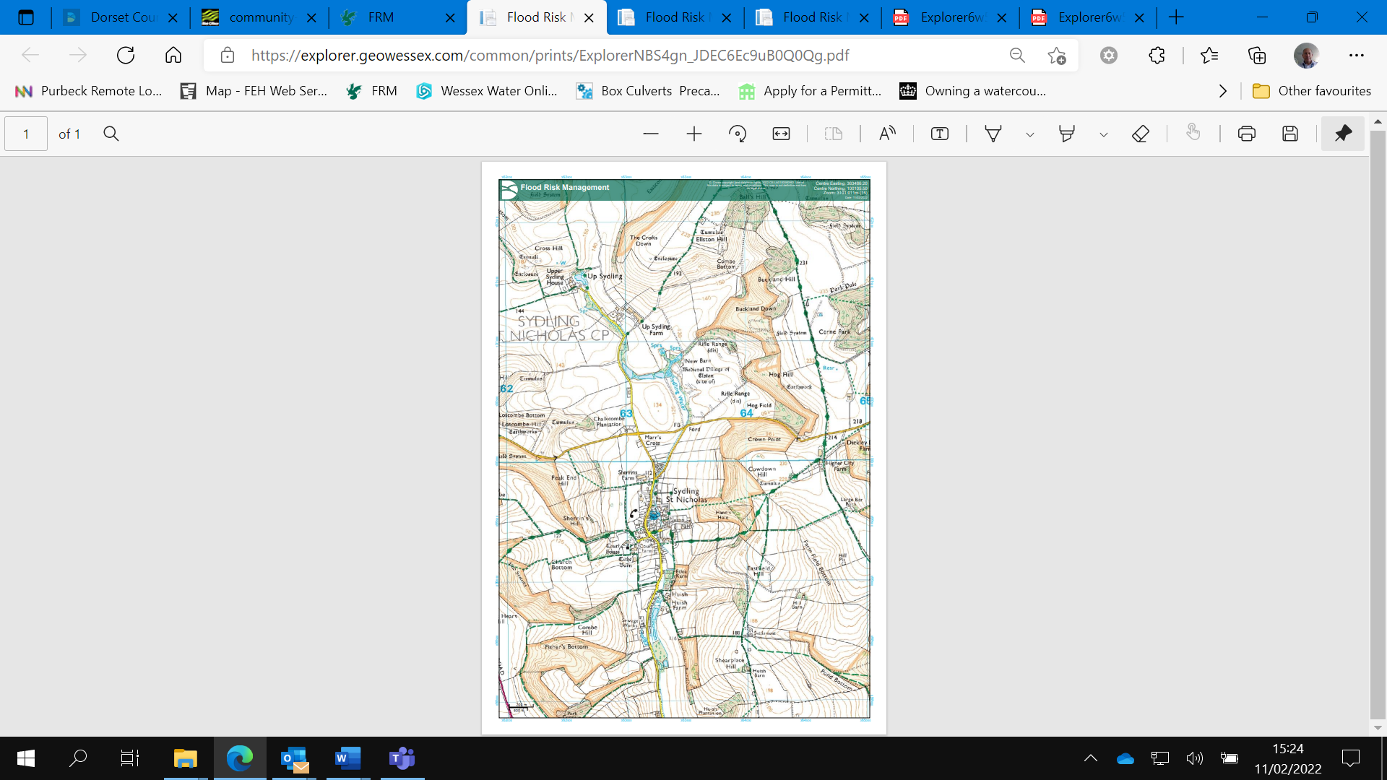

**This drawing Indicates the topography and elevations surrounding Sydling St Nicholas**

### 3.1 Geology and Hydrogeology

Predominantly Lower Chalk with small outcrops of Middle and Upper Chalk forming higher ground flanking the catchment. Land use is pastoral with some arable agriculture on flatter ground.

The bedrock geology is of a zig zag chalk formation. Sedimentary Bedrock formed approximately 94 to 101 million years ago in the Cretaceous Period. The local environment previously being dominated by warm chalk seas.

Superficial deposits are fluvial in origin, they are detrital, ranging from coarse-to fine-grained and form beds and lenses of deposits reflecting the channels and floodplains.

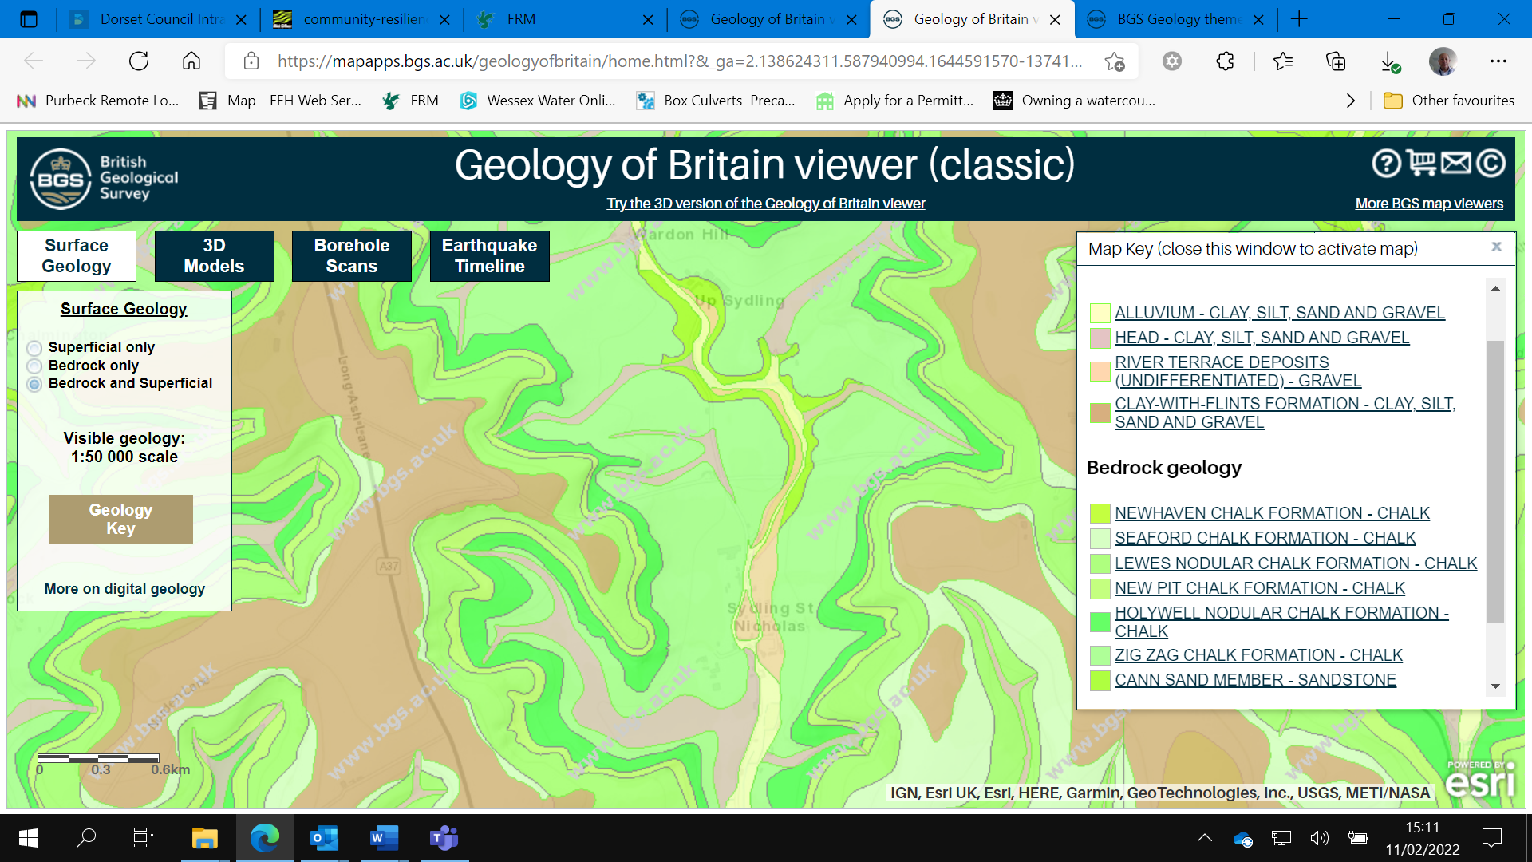

**Map of the Geology & Hydrogeology**

Hydrogeology - The Chalk is the major aquifer, or reservoir of underground water, in the catchment. Chalk is a porous rock, though it is mainly the cracks and fissures which allow it to transmit large quantities of water. The Upper and Middle Chalk are generally more permeable than the less well fissured and more marly Lower Chalk. There is probably hydraulic continuity between the Chalk and Upper Greensand, but it is likely that the Lower Chalk is sufficiently impermeable to reduce groundwater movements. Supporting evidence comes from the Upper Piddle where spring flows are found at the Upper-Middle Chalk boundary, resulting from water being unable to percolate down into the Upper Greensand. Beneath the Greensand is a layer of relatively impermeable Gault Clay. The sands and gravels of the lower catchment are relatively impermeable, which limits recharge to the aquifer and also gives rise to springs.

### 3.2 Hydrology

The natural flow of Sydling Water is mainly influenced by the geology of the catchment, predominantly spring-fed. In the summer, the water level in the chalk will fall, and some of the uppermost springs will progressively dry up.

This may lead to sections of the river ceasing to flow. Such flow as remains tends to be relatively stable because it originates from these springs; rainfall is largely absorbed by the soil. During winter the increased rainfall will eventually saturate the chalk, restoring the water level and the spring flows. Only when the aquifer is recharged will further rainfall run off directly into the river, giving rise to more variable flows.

The Environment Agency use the Dickley Down Groundwater monitoring bore hole for flood warnings for Sydling St Nicholas.

## Incident Summary

**Sydling St. Nicholas**

|  |  |  |  |
| --- | --- | --- | --- |
| Location | Number of properties flooded internally | Incident Date | Main source(s) of flooding during incident |
| East Street | 8 | 31/10/2021 | Surface water  Main River |
| High Street | 1 | 31/10/2021 | Surface water |

Properties Affected - Summary of properties flooded, (based on approximate numbers reported and brought to our attention during this investigation).

A yellow warning for heavy rain was issued by the Met Office and a number of Flood Alerts and Flood Warnings were issued in the Wessex area, as well as elsewhere across England. The Flood Guidance Statement at the time indicated a “yellow” (low) overall flood risk for the Wessex area: a medium likelihood of minor impacts (“heavy rain at times may lead to some localised flood impacts”). Local media reported many road closures due to fallen trees, unsafe structures and cars trapped in flood waters.

Subsequently, the Wessex area requested return period analysis for the event due to some gauges recording the highest maximum levels on record.

The Environment Agency have a flow monitoring station on the Sydling Water at Sydling St. Nicholas (NGR; **SY6323999649), this station records daily mean flow.**

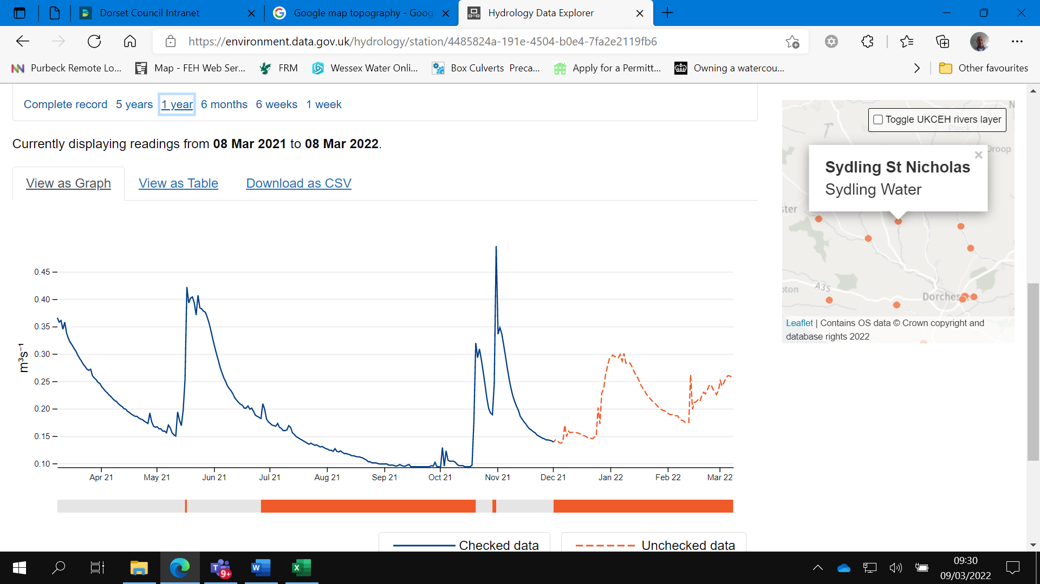

**The graph above shows the Sydling Water ‘Mean’ flow recorded between the 8th March 2021 & 8th March 2022, a significant spike in flow can be seen during the event of the 31st October.**

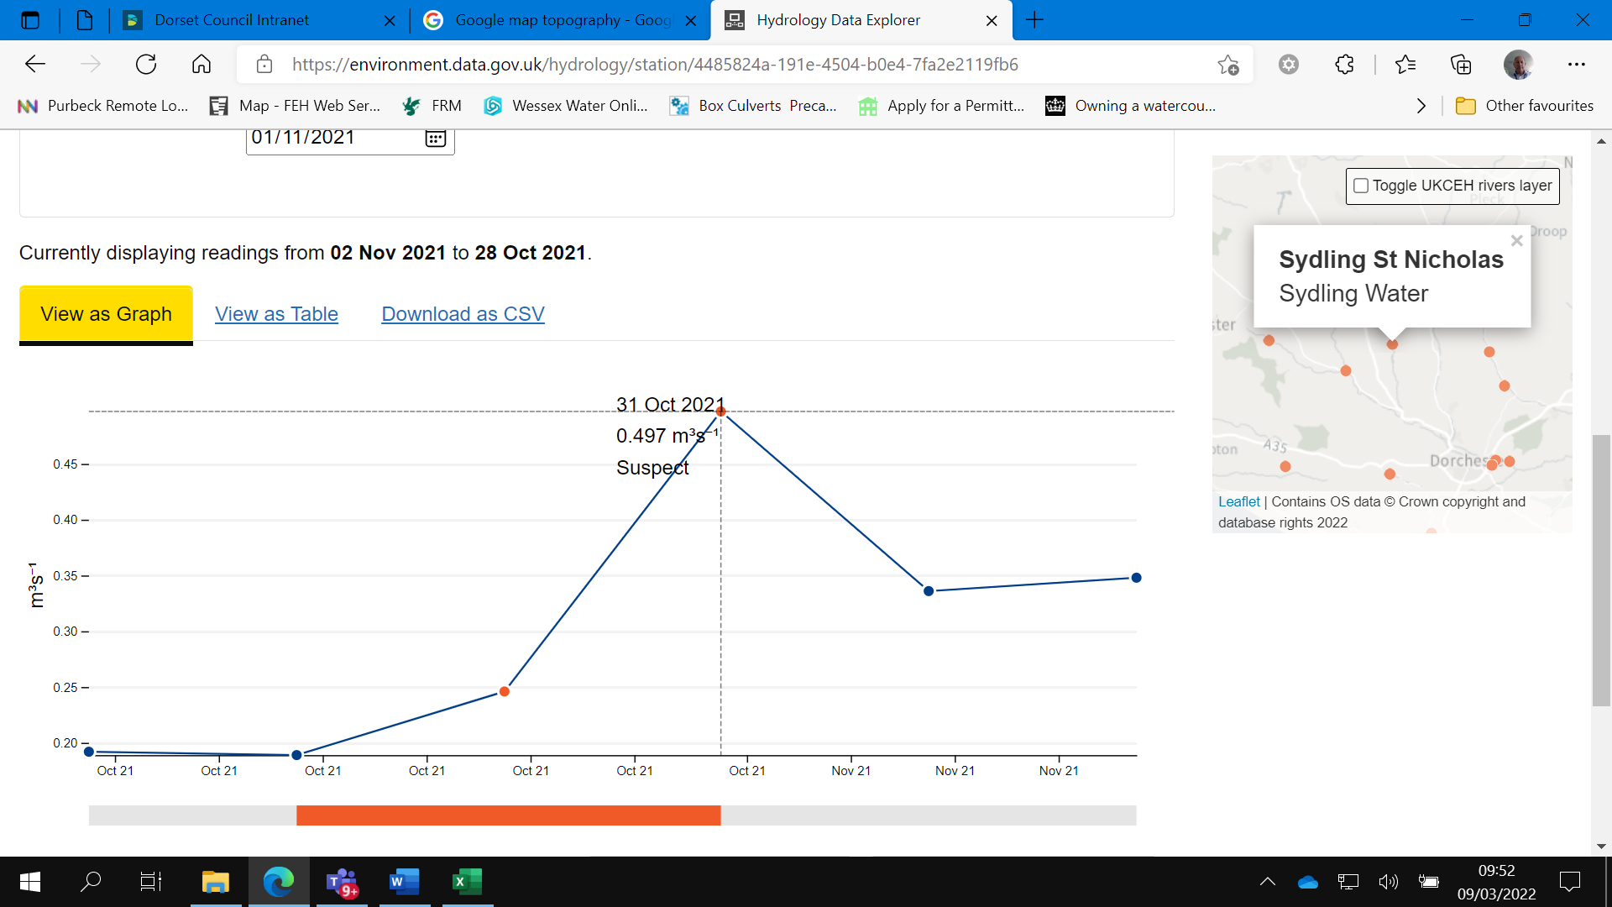

The graph above shows the Sydling Water ‘Mean’ flow recorded between the 28th October 2021 & 2nd November 2021. The recording reading is indicated as ‘suspect’ as flows had exceeded the tolerance of the monitoring equipment.

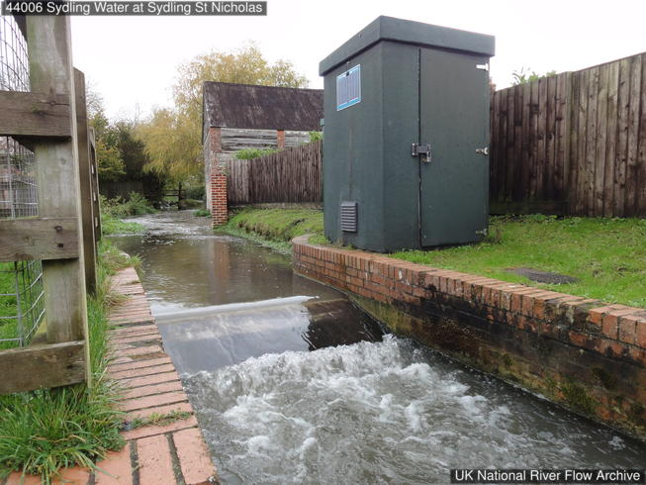

The Sydling St. Nicholas Flow Monitoring Station, (Environment Agency).

### 4.1 Rainfall data

October saw some particularly wet days, in fact nearly all 150mm fell in just 8 days at the beginning and end of the month and on the 19th / 20th.

Notable rainfall totals were recorded between 0800hrs and 0900hrs on October 31st at King’s Stag where 31.4 mm fell within the hour.

During the morning of Sunday 31st October 2021, a low pressure centre to the west of the UK led to a band of frontal rain moving in a north-easterly direction across the UK, bringing localised heavy rain and thunderstorms (Figure 1). This followed an earlier band of rainfall on Saturday 30th October.

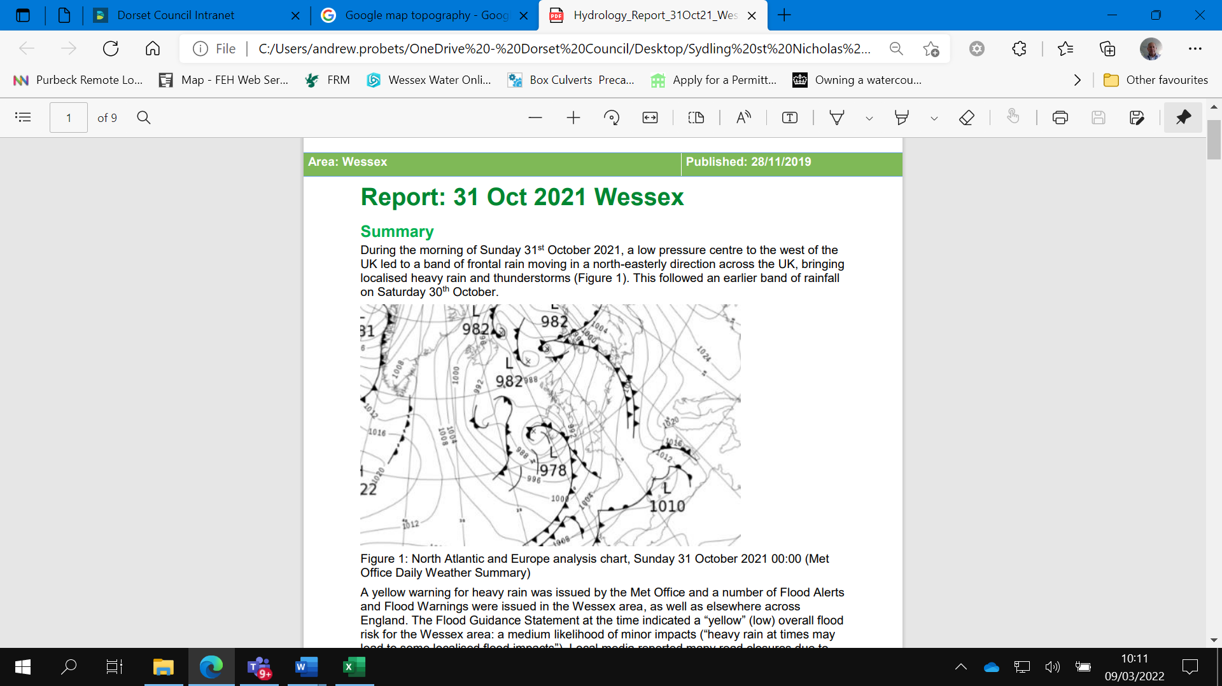

**Figure 1. -** North Atlantic and Europe analysis chart, Sunday 31 October 2021 00:00 (Met Office Daily Weather Summary)

Rainfall data indicates that rain began falling steadily in the Wessex area at around 4am

on the 31st October, rising to a peak in rainfall intensity at around 8am before clearing by 9am and remaining mostly dry for the rest of the day (Figure 2). Radar data indicates a band of particularly intense rain at 8.30am across western parts of the area.

Table 1 lists the peak rainfall amounts recorded over different durations during the event,

and the estimated return periods for those rainfall amounts. In most locations, the rainfall

was unexceptional (<1 in 2, or 1 in 2 to 1 in 5 return period). However, at King Stag Ridge Farm, the estimated return period was 1 in 25 years for the 1-hour duration rainfall. The table also shows the rainfall as the percentage of the long-term average (LTA) rainfall for October.

Moderately extreme rainfall was also recorded at gauges nearby, with return periods of

just under 1 in 10 years for the 1-hour duration at Gillingham Common Mead Lane and

Eggardon Hill.

These estimates indicate that the rainfall was locally extreme, but not consistently heavy across a widespread area.

The event rainfall represented 30 to 60% of the October LTA, with the highest percentage occurring at King Stag Ridge Farm. Other locations than those analysed here may have experienced more intense and extreme rainfall.

There is also uncertainty in the raw data and frequency analysis methods.

Therefore, this analysis should only be interpreted to indicate that the rainfall events were in some locations exceptional and rare.

#### Flood Hydrology Report Figure 3: Rainfall timeseries for 31st October 2021 (Hyrad H24 at Kingstag Ridge Farm rain gauge) Figure 3: Rainfall timeseries for 31st October 2021 (Hyrad H24 at Kingstag Ridge Farm rain gauge)

Figure 2: Rainfall timeseries for 31st October 2021 (Hyrad H24 at the Kings Stag Ridge Farm rain gauge)

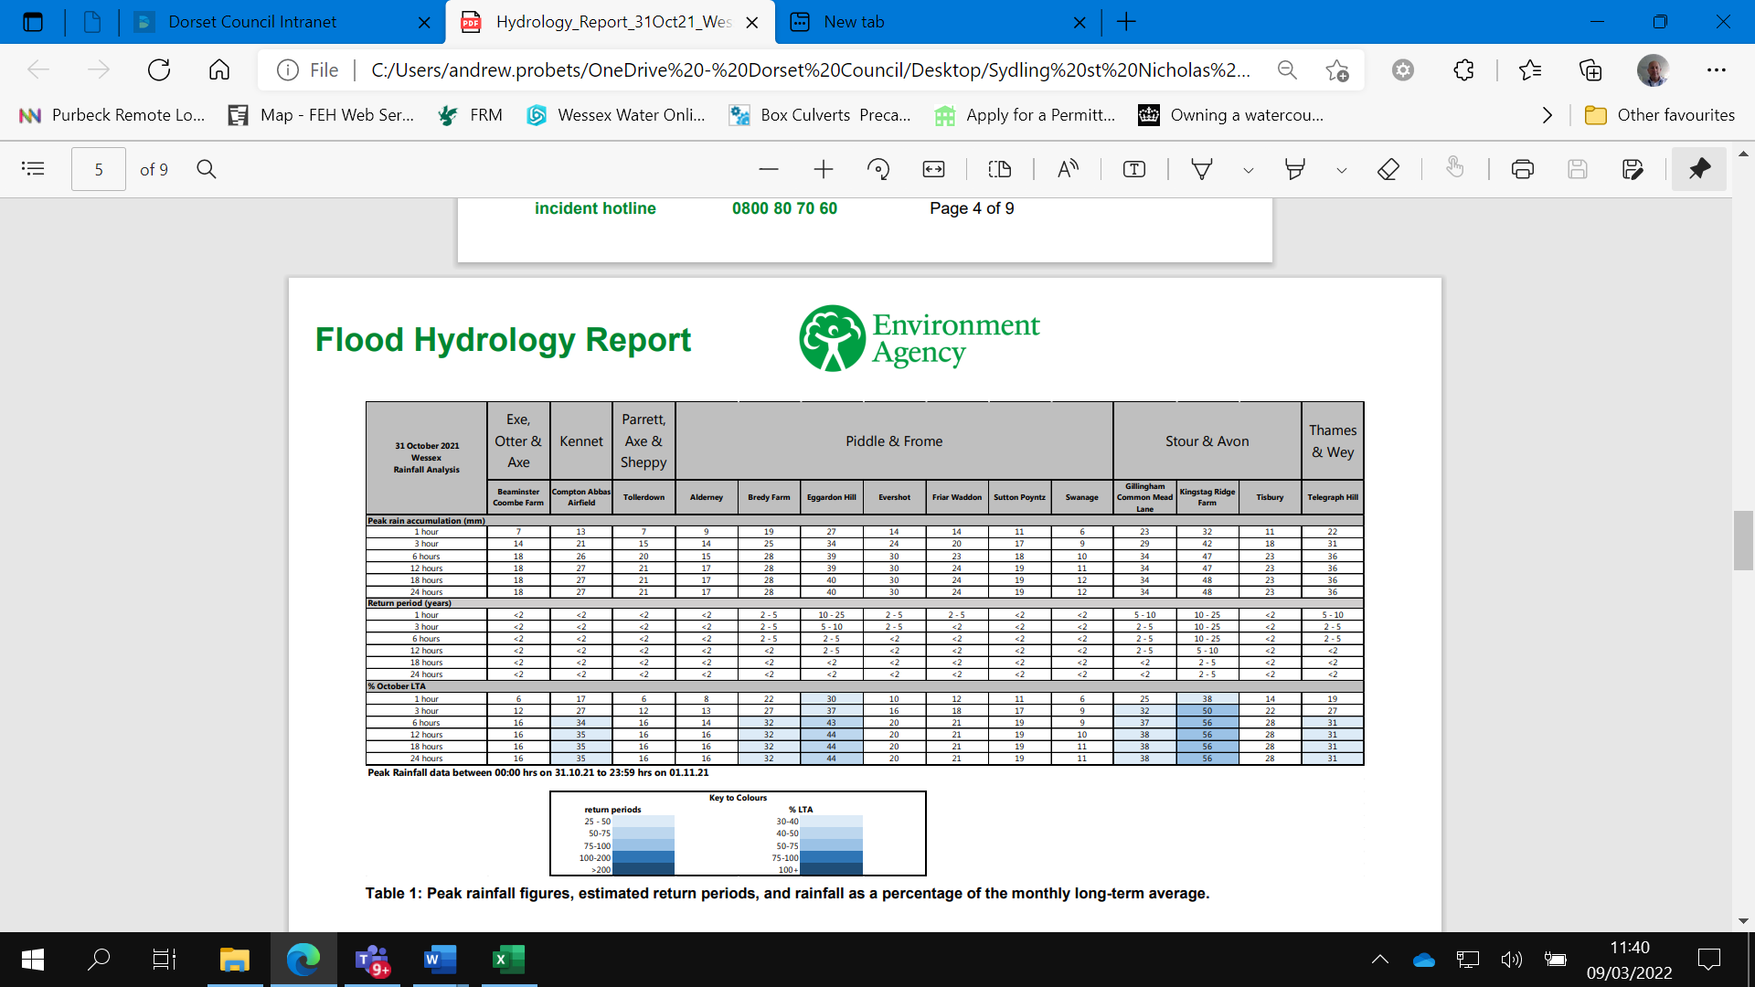

Table 1: Peak rainfall figures, estimated return periods and rainfall as a percentage of the monthly long-term average.

**River Levels**

River levels peaked between 8am and 2pm on the 31st October.

Table 2 compares the peak level reached during the event, highlighted in orange, with the previous top 15 ranked events for each location (peaks-over-threshold POT record). A number of notable previous events are also highlighted to provide context, including an event earlier in the month on 20th – 21st October 2021. At five of the stations analysed, the 31st October event ranked in the top three events, in records of 24 to 29 years length. This suggests this was an exception event for river levels at those locations. In other stations the 31st October ranked lower or outside of the top 15 events. This supports the rainfall data indicating that the even was locally extreme but not consistently so across a widespread area.

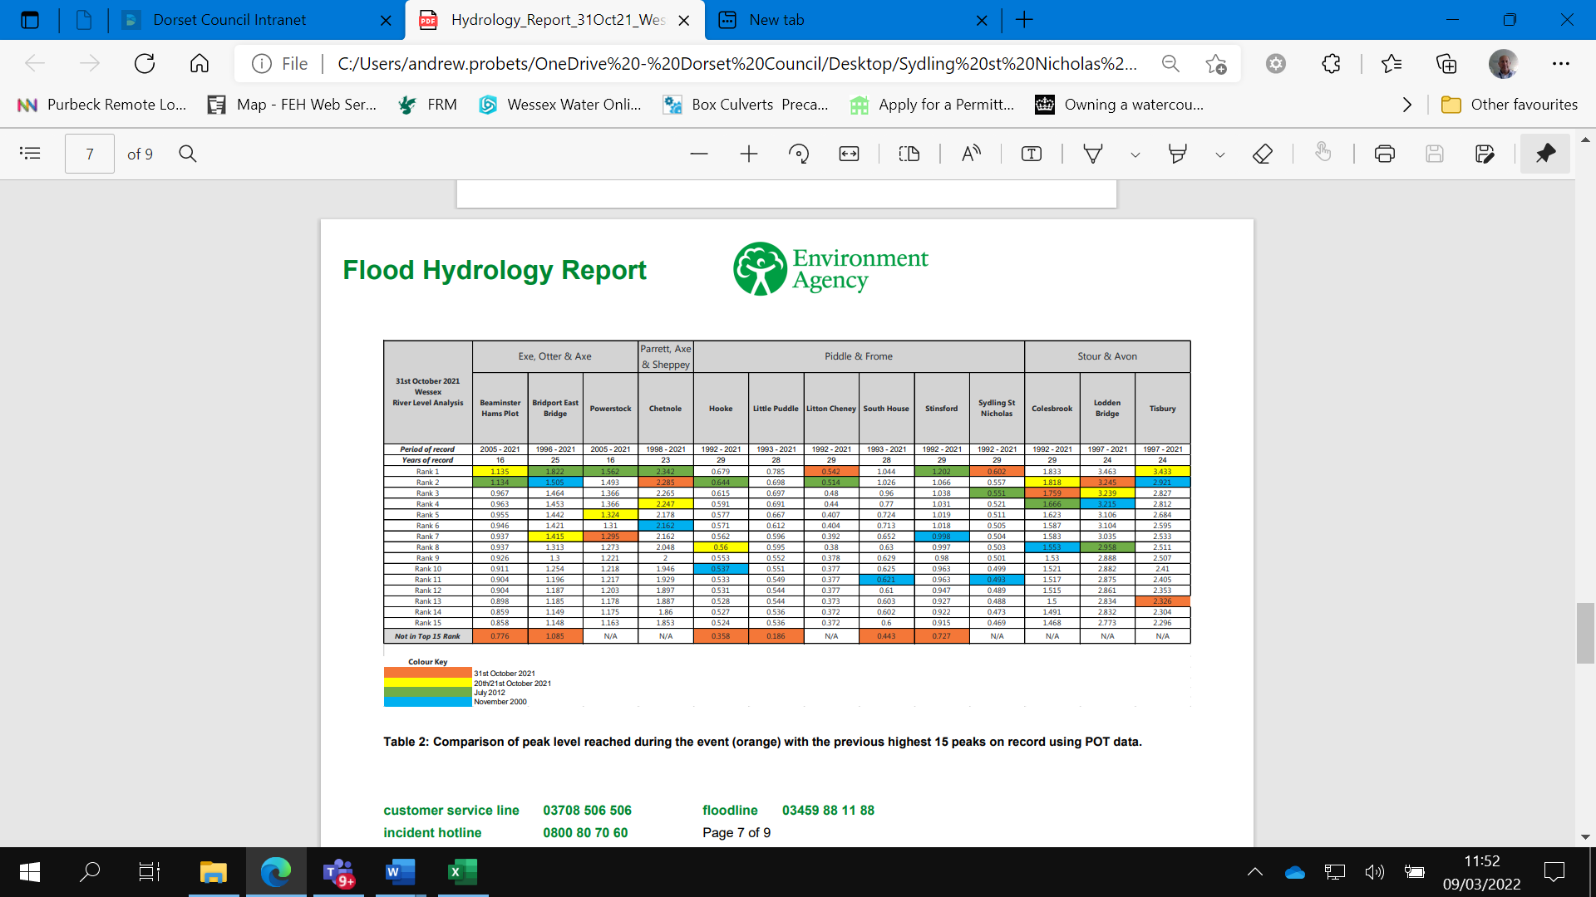

Table 2: Comparison of peak level reached during the event (orange) with the previous highest 15 peaks on record.

**Environment Agency Rainfall Gauge Locations**


Figure 3- Environment Agency Rainfall Gauge Locations


Dorset Council Rainfall Gauges, sited at DC County Hall and Piddletrenthide.

The period covers the 30th to 31st October 2021.

Dorset Council Rainfall Gauges, these are sited at DC County hall and at Piddletrenhide.
The period covers the 30th to 31st October 2021.


**1 hour rainfall accumulation for 31st October 2021 08:30 hours (Hyrad H24)**

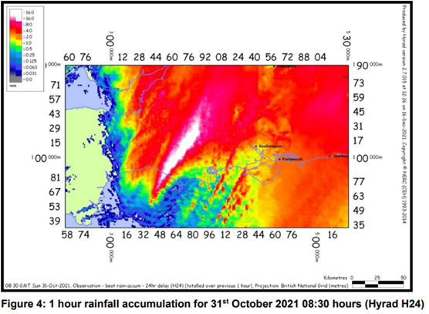

### 4.2 Locations Affected

The areas predominantly affected during the flooding event of the 31st October 2021 had been East Street and High Street. There is a flood alleviation scheme in High Street, Sydling St. Nicholas that is understood to have been constructed by the former West Dorset District Council.

#### 4.2.1 East Street

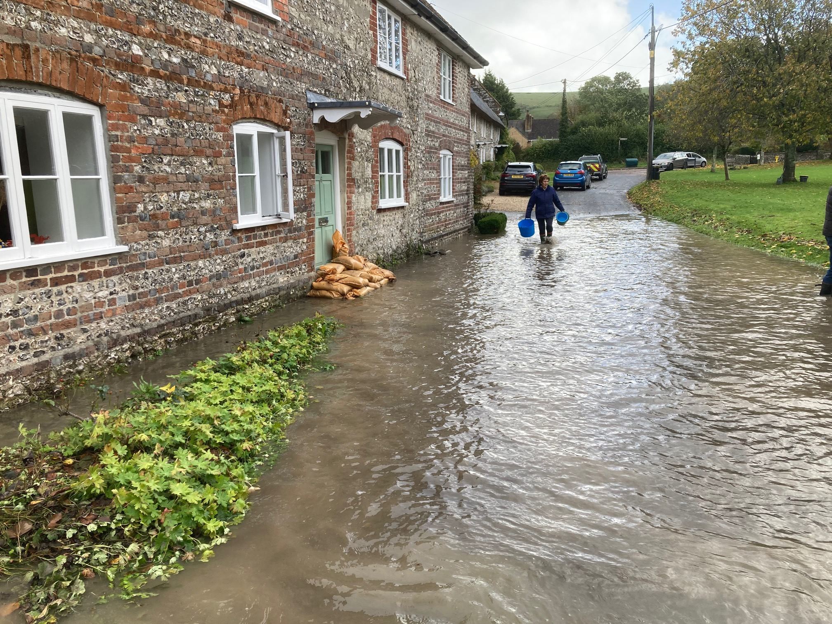

**East Street**

Many properties suffered internal flooding in ‘East Street’ during the event, the cause had been fluvial out of bank watercourse flows from Waterside lane, and surface water run-off from;

* Land to the east of Orchard Close.
* Land to the north of Cutlers Close, understood to enter Sydling Water via the garden of 6 Waterside Lane.
* Fields to the East of the village green.

#### 4.2.2 High Street

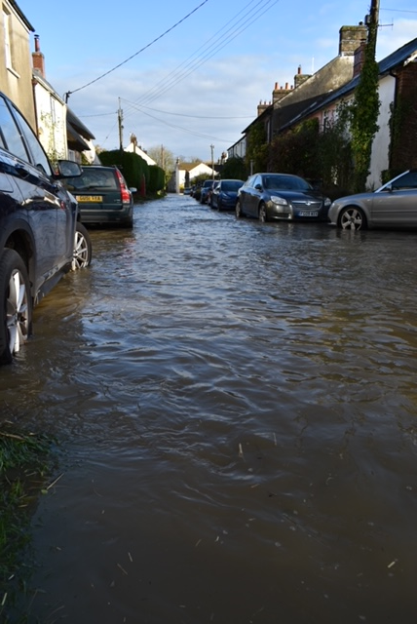

**High Street**

A single property suffered internal flooding in ‘High Street’ during the event, the cause had been surface water run-off from;

* Land north and south of Marr’s Cross
* Land to the east of Orchard Close.
* Land to the west of 17,19,21,23 High Street.

## Quick Wins

As part of the on-going investigation, a number of quick win schemes to reduce the impact of flooding were identified, that could be implemented quickly by the RMA’s or landowners within a short timescale and at relatively low cost. These have already been completed as this report has been progressed and are summarised in the table below:

Quick Win Schemes for Sydling St. Nicholas:

* The removal of timber structures from the eastern channel of the Sydling Water stream, upstream of Pitts Cottage and the Saw Mill. During the flood event of the 31st Oct. These obstructions had caused material to further partially block the channel. A letter has been sent to the relevant riparian landowner to request that these obstructions to flow are removed.
* Dorset Highways to review their highway drainage infrastructure in affected areas, and identify any further works required to ensure that the assets are in a good maintenance condition. The FRM engineer will discuss the matter with the Community Highways Officer.
* Dorset Council FRM and the EA to carry out a walk-over at Sydling St. Nicholas. This has already been carried out and locations have been identified where surface water run-off and silt are believed to be entering Sydling Water during prolonged/high intensity rainfall events, a conversation has started with partners to consider opportunities for natural land management processes in order to slow and reduce the volume of water and silts entering the stream. (A community drop-in event organised by the EA had been held on the 18th May 2022 where further information had been received and included in this report).

## Recommended Actions

As a result of this investigation report, several recommendations have been made for actions to be taken in specific locations. These are either as a result of initial site or desktop investigations, or the continuation of works or investigations already in progress. There are also a series of general actions recommended to be considered in all of the locations

**Table 2 Recommended Actions for Sydling St Nicholas**

### General Actions

#### Action by: LLFA/EA/ Local Communities

Recommended action: Increase community resilience to flood events.

How:

* The relevant authorities will help assist with the development of community flood resilience plans.
* Review current Parish sandbag arrangements.
* Discuss available NFM and land management measures with colleagues at the EA, AONB, CSF and FWAG.
* Catchment walkover and desk based exercise to assess catchment processes to identify issues and Natural Flood Management related solutions to reduce run off and slow the flow upstream of the community with development of a catchment (NFM)plan
* Support development of local ‘Flood Action Group’ or community group to pick up and deliver Catchment Plan to reduce flood risk (NFM).
* Discuss the Sydling St Nicholas Flood Management Plan with the Parish Council and Parish Flood Warden.

Start of a flood action group within the village. [What is a Flood Action Group? – National Flood Forum](https://nationalfloodforum.org.uk/working-together/communities/what-is-a-flood-action-group/)

* Ensure that the location of any vulnerable residents is known.

#### Action by: DC Highways

Recommended action: Ensure efficient operation of highway drains and culverts.

How:

* Review highway gullies and consider whether any maintenance issues require attention.
* Could any improvements be offered to the Highways drainage scheme in East Street and High Street (including the flood alleviation scheme in the High Street that had been constructed by the former West Dorset District Council no doubt under best endeavours at the time).

#### Action by: LLFA/EA/Property Owners

Recommended action: Consider flood resilience measures.

How:

* Provide information to property owners such as the ‘Blue Pages directory’ measures might include flood gates and waterproof air vents.
* Sign up to EA Flood Alerts.

EA - To look at the possibility of providing a fluvial flood warning service and a monitoring gauge.

EA – To offer PFR to Sydling

* EA- Ensure residents are signed up to the groundwater flood warning.

#### Action by: Property Owners

Recommended action: Consider flood risk to properties.

How:

* Ensure riparian owned watercourses are maintained without obstruction to flow.
* Discuss the responsibility to protect their property from flooding and having sandbags available at short notice.

### East Street

#### Action by: DC Highways

Recommended action: Ensure efficient operation of highway drains and culverts.

How:

* Discuss with the Community Highways Officer.

### High Street

#### Action by: LLFA/EA

Recommended action: Ensure that downstream riparian landowners remove obstructions to flow from watercourses.

How:

* A letter has been sent to the riparian landowner of the ordinary watercourse north of the Mill, FRM Team to investigate outcomes.

#### Action by: DC Highways

Recommended action: Ensure efficient operation of highway drains and culverts.

How:

* Discuss with the Community Highways Officer.

## Next Steps

The next steps following this report will be for Dorset Council as the LLFA to ensure that the recommended actions are taken forward by the identified Risk Management Authorities. Dorset Council will monitor actions through regular reviews, whilst working in partnership with the EA, other Councils, Wessex Water and the local communities affected.

* Arrangements are being discussed with the EA and Parish Council to hold a drop-in event at the Village Hall, this would give affected residents the opportunity to discuss the flood event and mitigation measures that they could considered for their properties, as well as measures being considered by others to reduce the flood risk where possible.
* Relevant agencies to follow up the steps in ‘Recommended Actions’ above.
* EA- Study to understand flood mechanisms within the catchment and offer PFR to the community.

## Appendix 1 – Catchment of the Study Area

