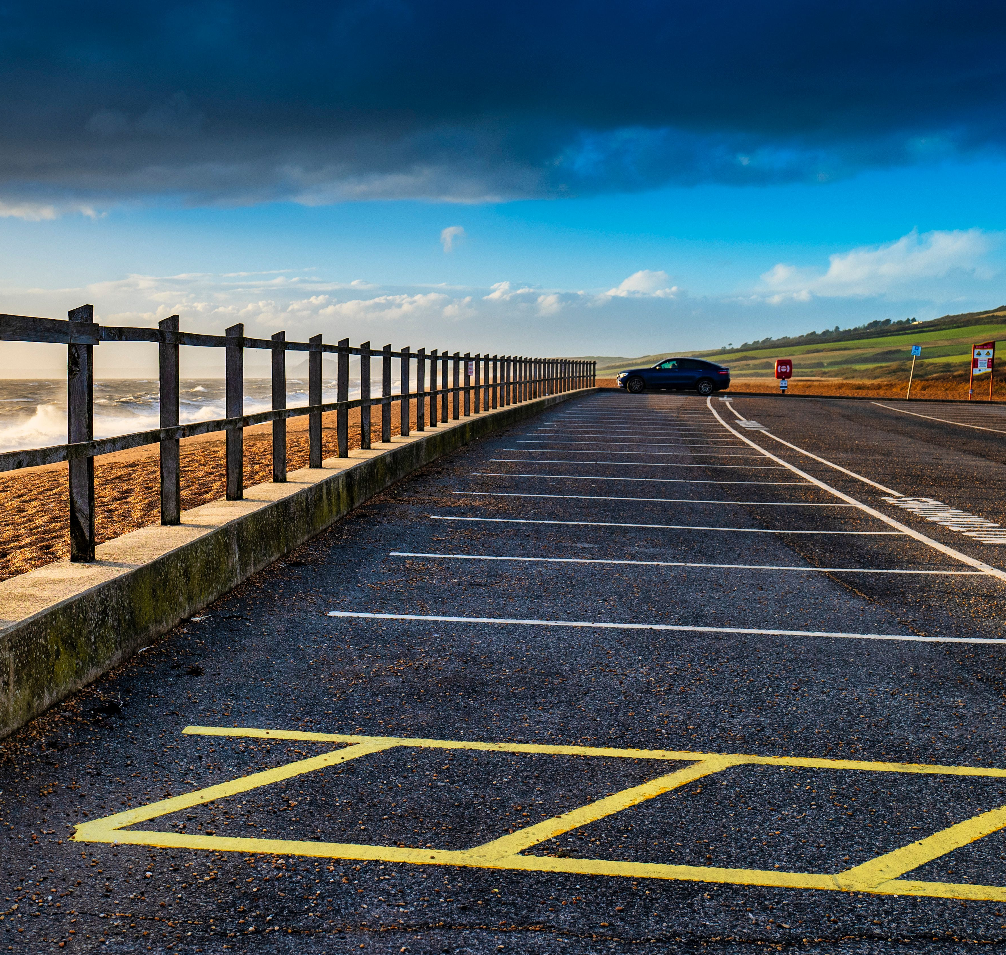

Parking Services
Annual Report
2021/2022

www.dorsetcouncil.gov.uk/parking

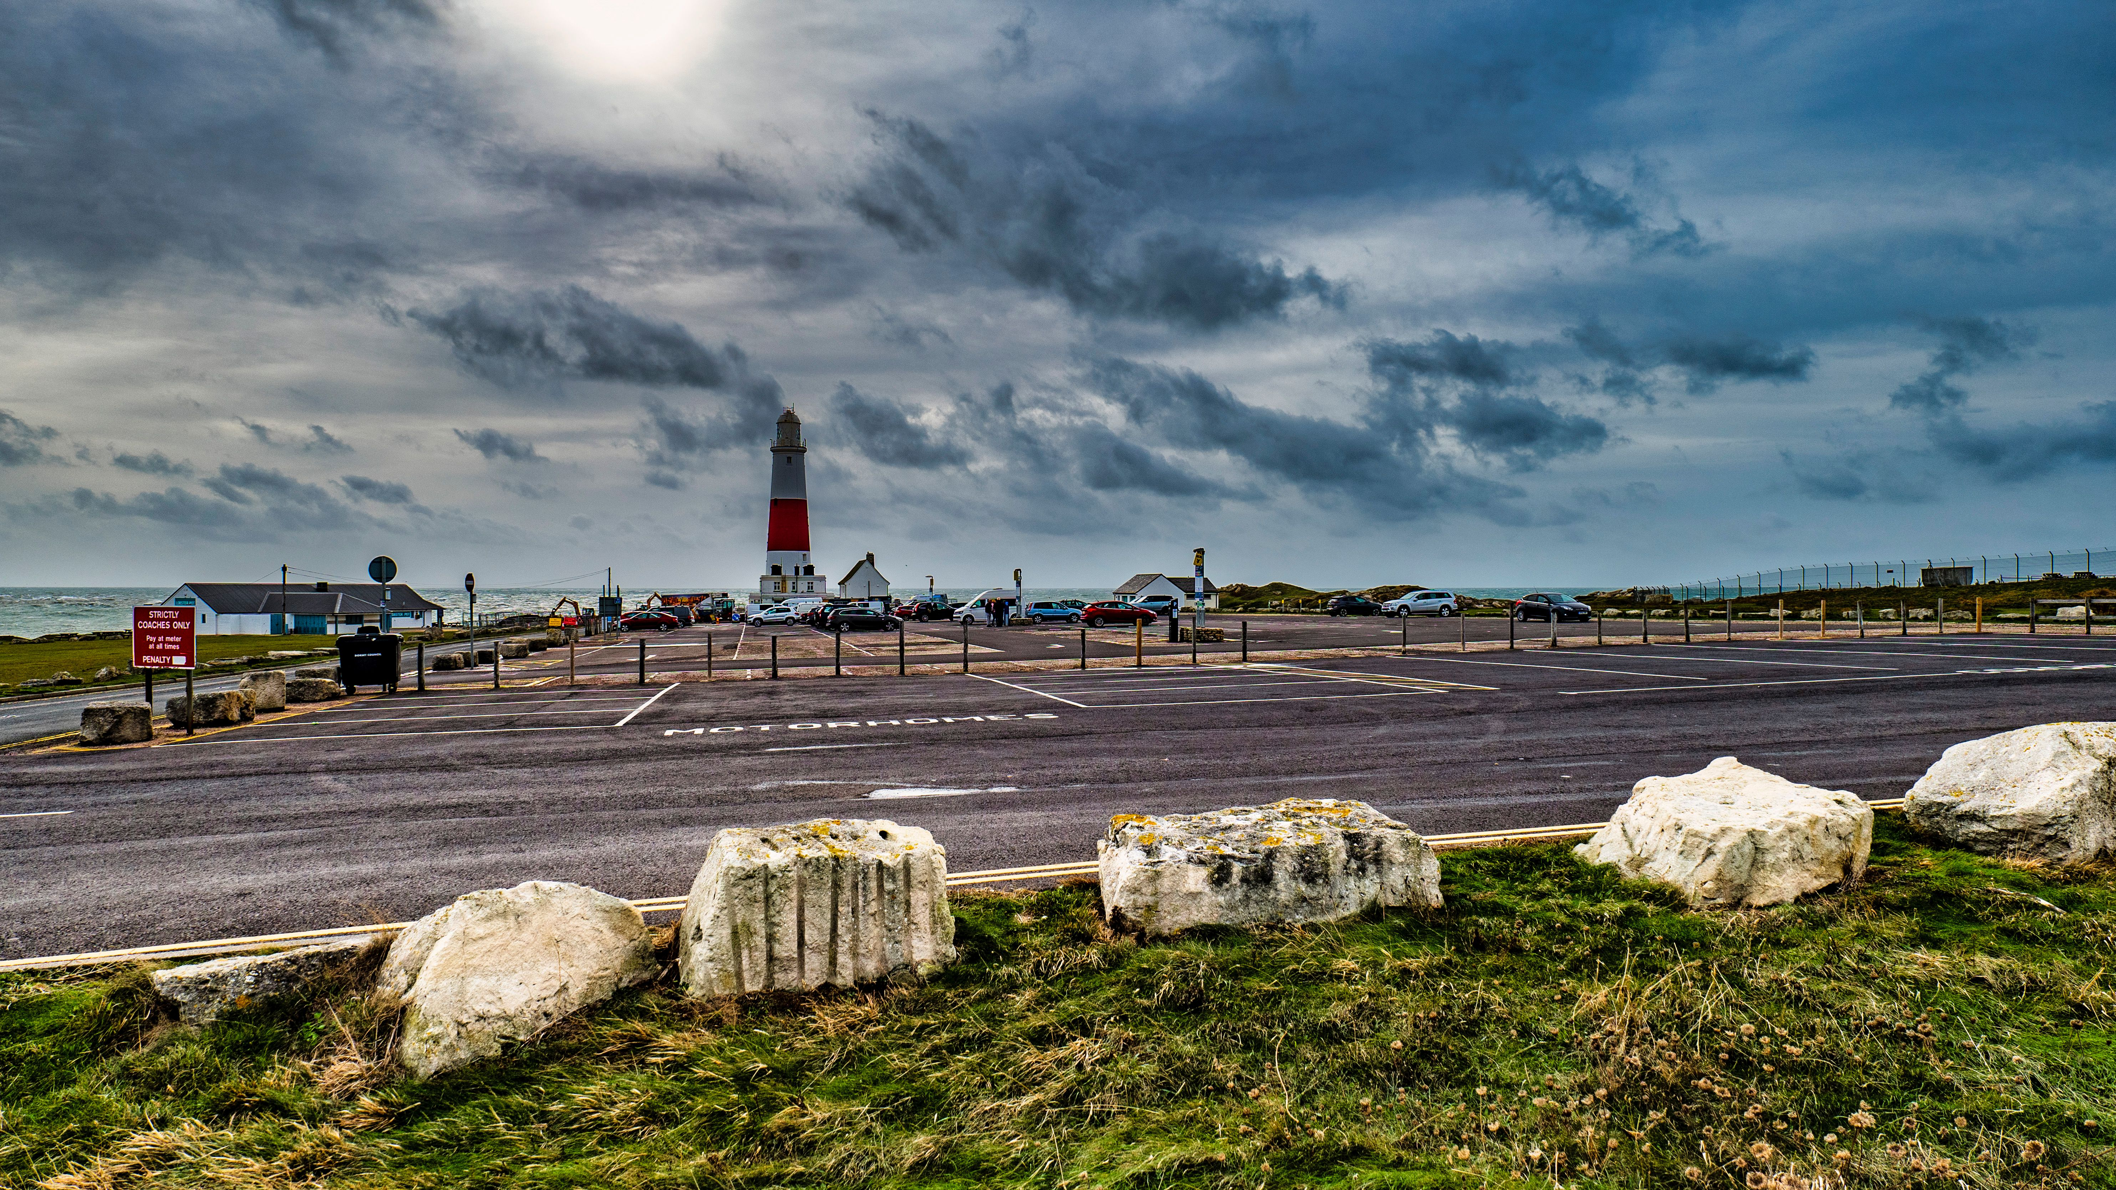

Forward
Councillor Ray Bryan
Portfolio Holder for Highways, Travel and Environment
Welcome to the Parking Services annual report for Dorset Council for 2021/2022.
Parking remains an important element to the services we deliver as a Council, to ensure parking regulations are upheld which helps to keep traffic moving and provide a safe environment for pedestrians, cyclists, and all road users.
This year we continued the work on aligning former charging strategies for the purpose of enabling fair and consistent charging. This included the proposing of 3 tariff levels, the purpose of which to acknowledge the uniqueness of Dorset’s rural, market towns and tourist locations.
The second part of the year saw us saying a fond farewell to our Parking Services Manager, Paul Hutton, I thank him for the great work that he did whilst heading up the team. We welcomed in Mike Westwood as the new Parking Services Manager. Mike brings great knowledge with him, having had over 20 years’ experience working in highways both for external organisations and within Dorset Council. Mike aims to continue the work of bringing the parking team together and aspires to make service and parking improvements to improve our customers’ experience when using our parking and contacting the service.

Introduction
The purpose of this report is to provide financial, statistical and performance data
relating to Parking in Dorset Council, and covers the period from 1 April 2021 to 31 March 2022. Reports for previous years can be found on Dorset Council’s website at https://www.dorsetcouncil.gov.uk/parking

Enforcement

The table below shows the number of PCNs issued from 2020/2021 to 2021/2022, categorised by the type of contravention and level of PCN.

PCN statistic | 2020/2021 |  | 2021/2022
 | On-street | Off-street | On-street | Off-street
Higher Level PCNs issued | 10190 | 997 | 10075 | 1136
Lower Level PCNs issued | 5057 | 7797 | 4748 | 10017
Total PCNs issued | 15247 | 8774 | 14823 | 11153
PCNs paid at discount rate | 10024 | 4807 | 9195 | 6413
PCNs paid at non-discount rate | 1674 | 889 | 2036 | 1393
Total PCNs paid | 11698 | 5696 | 11231 | 7806
Total PCNs unpaid | 3549 | 3078 | 3592 | 3347
PCNs registered as Debts | 2658 | 886 | 2959 | 1679
Appeals/Representations received | 3229 | 2548 | 2864 | 3160
PCNs cancelled through the use of discretion or due to evidence being supplied | 893 | 1454 | 756 | 1556
PCNs cancelled for statutory reasons | 75 | 30 | 36 | 36
Total PCNs cancelled | 968 | 1484
PCNs going to Adjudication | 21 | 6 | 7 | 2
PCNs written off (untraceable keepers) | 270 | 238 | 235 | 132
Vehicles clamped or removed | 0 | 0 | 0 | 0

Financial Data

Income and expenditure statement 2021/2022

 | 2020/2021 (£) | 2021/2022 (£)
Expenditure
Internal Charges (Expenditure) | 166,924 | 264,418
Pay Related Costs | 1,489,114 | 1,224,147
Premises Related Costs | 1,527,441 | 1,618,602
Transport Related Costs | 57,861 | 43,811
Supplies and Services | 602,098 | 606,605
Third Party (Contracted Out) Payments | 6,264 | 14,485
Total Expenditure | 3,849,703 | 3,772,068
Income
Parking Waivers & Permits | 676,693 | 728,849
Pay & Display Charges | 2,988,444 | 3,260,222
Mobile Phone Charges | 1,447,804 | 4,403,500
Penalty Charge Notices | 692,197 | 742,712
Internal Charges (Income) | 2,832,766 | 21,868
Government Grants |  | 153,759
Other income | 303,903 | 172,843
Total Income | 8,941,809 | 9,483,753
Financial adjustments | 84,161
Deficit/Surplus | 5,176,265 | 5,711,685

